Welcome to BC3010 – Advanced Peer Leadership

BC3010 - Course Description

This course will allow students in Peer Leadership roles to further develop their skills as leaders. Through extensive training and hands-on experience students will learn about group dynamics, interpersonal communication skills, conflict resolution and the different levels and forms of leadership. Using these skills, students will be able to effectively lead teams of diverse individuals in both on and off-campus environments

Overall Course Learning Objectives:
Upon successful completion of the course, students will be able to:
- Improve and develop their communities by utilizing leadership and peer-mentoring skills acquired in the course
- Apply leadership and mentorship skills gained to take on leadership roles on campus.
- Create and carry out a strategic vision for at an individual or organizational level
- Restructure and strengthen peer leader based programs while respecting shared values, visions, missions and goals of the program
- Use interpersonal communication skills to help peers identify their challenges, educational goals, and career goals and create a strategic plan to address them.
- Work and communicate effectively in diverse groups.
- Create and deliver seminars, workshops and training sessions.
Class Schedule: Thursdays 4 – 5:30pm in CB124.

Notes on course structure:
Most of in-class time will be spent in peer discussions or working on/presenting course material. Therefore attendance is expected.
We will use Moodle to further classroom discussions, complete some activities and share course material
Instructor Information: Dr. Tanya Da Sylva
Office: 210 Bethune College
Email: dasylva@yorku.ca
Office Hours: posted to Moodle. If you can’t make office hours, please email me to arrange an appointment. You’re welcome to stop by my office at anytime, but I may not be there if you haven’t arranged an appointment

Notes on email communication:
Please place the course code (BC3010) in the subject line of any email you send me.
I receive a large volume of emails every day; having a descriptive subject line helps me address your email in a timely fashion. You can expect an average response time of three business days.
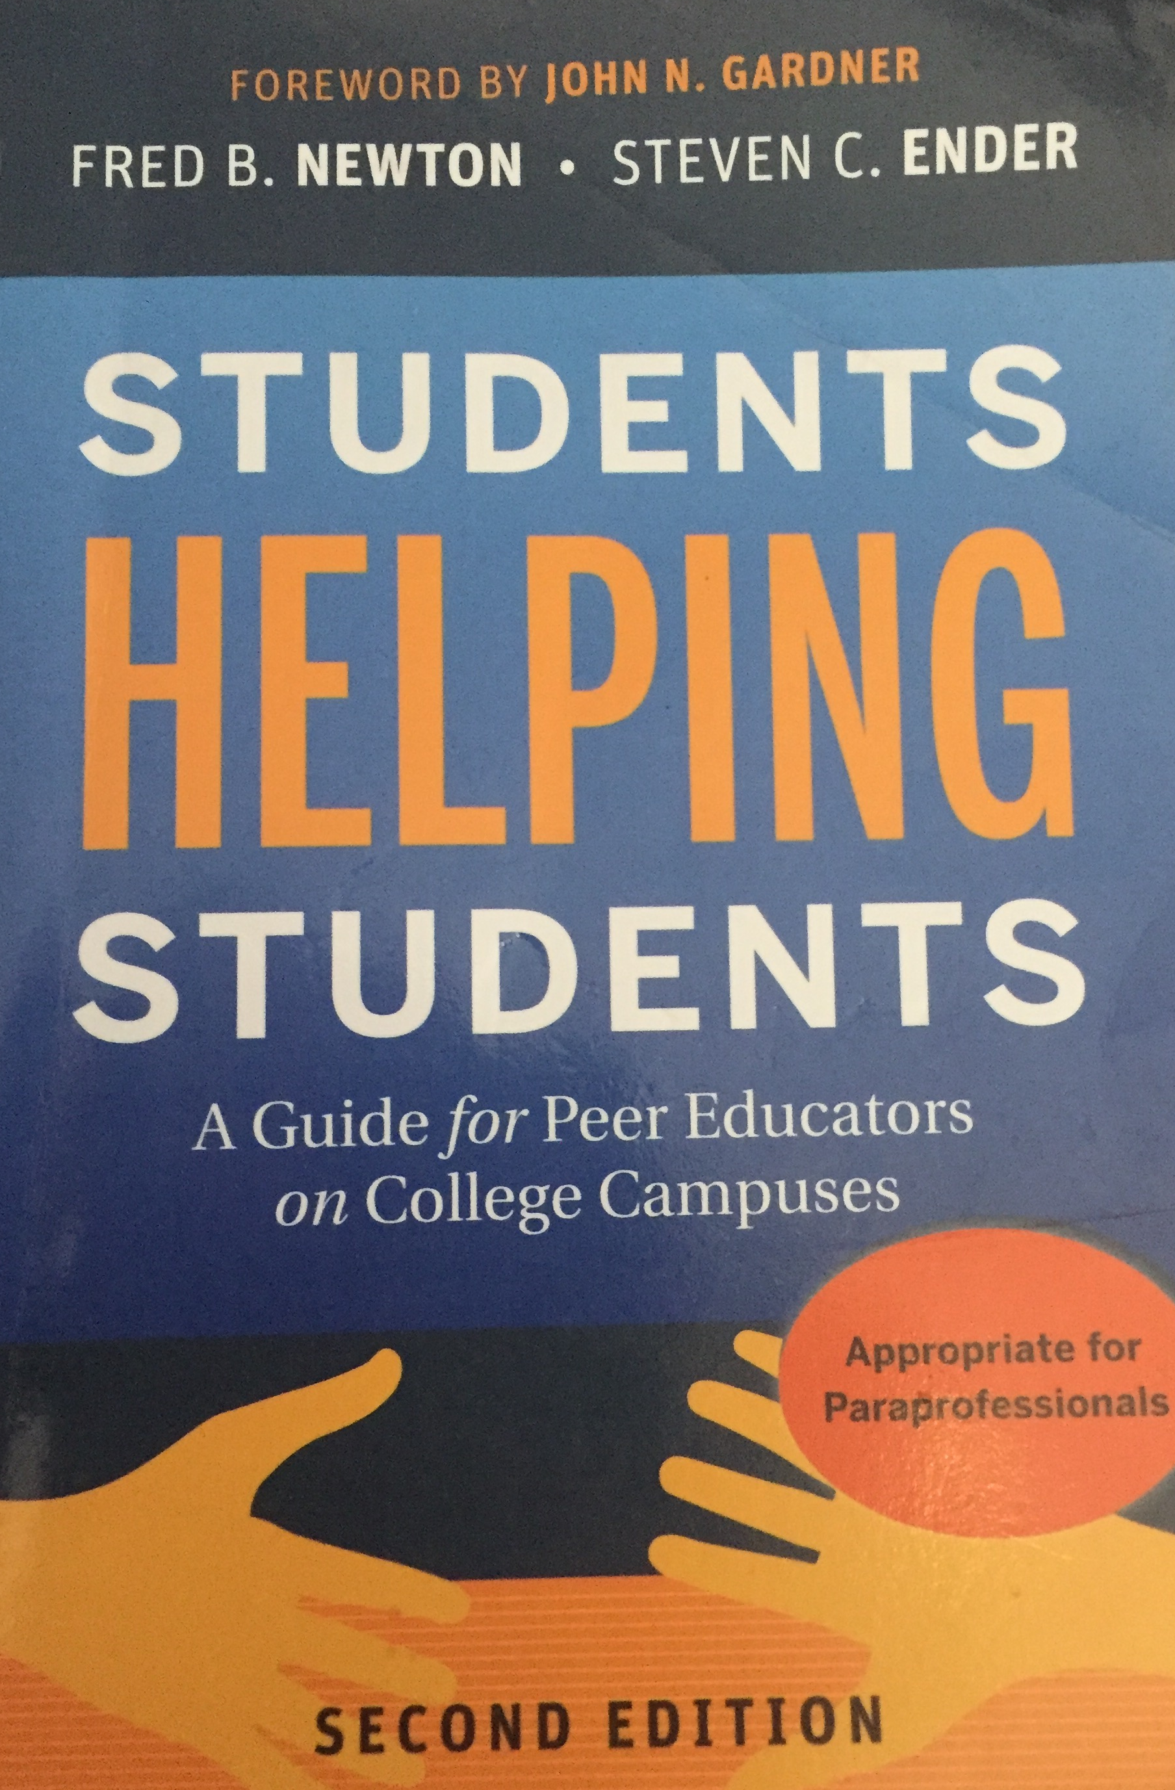
Textbook:
Students Helping Students: A Guide for Peer Educators on College Campuses. 2nd Edition; by F.B. Newton and S.C. Ender
Students Helping Students will be available in the bookstore; it is also available through the Toronto Public Library (and may be available through other public libraries) and through York Libraries. Any edition is acceptable.
Journal – You will need to record your reflections on the textbook while reading and also record some in-class discussions. I must be able to sign your notes to verify they were completed by assigned class periods. You will hand in the journal at the end of the Fall term (Dec. 4th). You may purchase or use any journal you like, or use loose leaf paper (but you are responsible for ensuring all the papers stay together).
Evaluation: There are five main components to the course plus participation.

Textbook Reflections:
Select chapters from Students Helping Students will be assigned throughout the term. You will be expected to read the chapter(s) and reflect on your readings before class. You will be given questions/prompts to guide your reflection. During class you will participate in peer-discussion and activities based on your readings and reflection. You will record your reflections/discussions in your journal and show them to me by the end of class. More information can be found in the Textbook Reflections Assignment Outline posted to Moodle. Each reflection is worth 3% of your final mark (four reflections = 12%); reflections are finished and handed in during class on:
Reflection 1 – due September 20th, 2018
Reflection 2 – due October 18th, 2018
Reflection 3 – due November 1st, 2018
Reflection 4 – due November 22nd, 2018

Leadership Portfolio:
You will create a portfolio (or e-portfolio) documenting your acquisition of leadership skills. Prompts and format requirements can be found in the Leadership Portfolio Assignment Outline on Moodle.
You will be composing four portfolio entries. The first two will be reviewed by a peer and not marked by me. Everyone will serve as a reviewer and your work as a reviewer will be part of your mark. I will mark your last two entries. Please see the assignment outline for more details.
Your leadership portfolio is worth 20% of your final grade.
Drafts/plans of your portfolio entries must be brought to class for discussion on the following days: October 4th and January 24th.
Portfolio Due dates:
Two entries (entry 1-2) submitted to a peer for review by Nov. 15th, 2018 (1%). Complete and return your review of their work to your peer by Nov. 29th, 2018 (9%).
Two new entries (entry 3-4) submitted to me by Feb. 7th, 2019 (10%).

Leadership Project:
You will apply your leadership skills to complete a project for a service group on campus. This project may take many forms and be in service to any official campus group. The project is expected to take at least ten hours of work and the service’s leader must approve your project. Before starting the project I must approve a Project Plan. At project completion you will hand in a brief report of your work and give a presentation on your work during class. More details can be found in the Leadership Project Outline on Moodle. Your Leadership Project is worth 30% of your final grade.
Due dates:
Project Plan (5%) – due October 25th, 2018
Project Progress Report (10%) – due January 7th, 2019
Final Project Report & Presentation (15%) - due March 21st, 2019 (if necessary we will use March 28th however you must be prepared by Mar. 21st).

Research Presentation:
You will research the use of peer educators in higher education; addressing why and how peer educators are used and the positive and negative aspects of their use. Research areas may vary substantially and guidelines can be found on the Research Presentation Assignment Outline posted to Moodle.
You will share your research findings with the class by creating a video presentation that you will post to Moodle. Once videos have been posted you will be assigned to groups in class to share and discuss what you have discovered. After the class discussion session(s) you will submit a written report following the instructions given in the assignment outline.
Your research presentation is worth 20% of your final mark (2% in-class discussion; 13% video presentation; 5% written report).
An outline/draft of your research presentation must be brought to class on Jan. 18th so that you can receive peer feedback before completing your video.
Due dates:
In-class discussions may take place over many weeks; you should be prepared to begin on Feb. 28th, 2019.
We will decide together when videos should be uploaded to allow for discussions to begin on Feb. 28th. Once we decide as a class, the due date will not be extended.
Final written reports are due April 3rd, by 5pm.

Examples of Leadership:
Leadership takes on many forms, from informal (e.g. peers organizing study groups in the classroom) to formal (e.g. business managers and executives). As you learn more about being a leader you should become more aware of other leaders and their skills (or lack-thereof).
You will present to the class an example of leadership. You can use examples from the media or your personal experiences. You will post your example to a Moodle forum where you will use discussion questions to encourage responses from your classmates. You must post an example and respond to at least two of your peers. Online discussions may be followed by in-class discussions.
For each assignment – your post is worth 4% of your mark and your response to peers is worth 1% (2 assignments X 5% = 10% of your mark).
Due dates:
1st Examples of Leadership Assignment – post to Moodle due by Jan. 10th, 2019; response to at least two peers’ posts due by Jan. 17th.
2nd Example of Leadership Assignment – post to Moodle due by Jan. 31st, 2019; response to at least two peers’ posts due by Feb. 7th.

Participation:
In-class: class attendance is mandatory; you must attend at least 80% of classes. You must also participate appropriately, which requires you to come prepared. You are expected to engage with your classmates/instructor/guests respectfully and contribute meaningfully to all in-class discussions and activities. I understand that there may be special circumstances that interfere with regular class attendance. Please discuss circumstances and accommodation needs with me (Dr. T. Da Sylva; dasylva@yorku.ca).
Participation is worth 8% of your final grade.

Accommodations:
York senate policy on Academic Accommodation for Students with Disabilities:
http://www.yorku.ca/secretariat/policies/document.php?document=68
“York University shall make reasonable and appropriate accommodations and adaptations in order to promote the ability of students with disabilities to fulfill the academic requirements of their programs”
If you feel that there are extenuating circumstances that may interfere with your successful completion of your course requirements you are encouraged to discuss your concerns with me (T. Da Sylva) as soon as possible. Students with learning, mental health, physical, sensory and medical disabilities who require accommodations in teaching style or evaluation methods should discuss the matter with Counselling and Disability Services (CDS - N110 Bennett Centre; http://www.yorku.ca/cds/) and the Course Director (T. Da Sylva) early in the term so that appropriate arrangements can be made. Please note: you are not required to disclose the nature of your condition. If you are registered with CDS. I will work with CDS to ensure all reasonable accommodations are met.

Grading and Incomplete/Late Work Policies:
The grading scheme for the course conforms to the 9-point grading system used in undergraduate programs at York (for a full description see the York University Undergraduate Calendar – http://calendars.registrar.yorku.ca/2012-2013/academic/grades/index.htm) Final course grades may be adjusted to conform to Program or Faculty grades distribution profiles.
Students may take a limited number of courses for degree credit on an ungraded (pass/fail) basis. For full information on this option see Alternative Grading Option in the Science section of the Undergraduate Calendar.
Late/Missing Assignments: You are expected to complete assignments on time. Late assignments will have 10% per day deducted from the grade. Assignments more than 48 hours late will receive a zero.
Participation: Participation is expected including attendance in class. You must attend at least 80% of scheduled classes and come prepared.
I understand that there may be special circumstances that interfere with regular class attendance or may interfere with class assignments. If possible, you should discuss these circumstances with me (T. Da Sylva) before the due date of an assignment. Please see above for the official Accommodations policy.

Academic Honesty:
York’s policy on Academic Honesty can be found here: http://www.yorku.ca/secretariat/policies/document.php?document=69
Any suspected violations of academic honesty will be taken seriously and immediately referred to the Dean’s Office.
York has numerous resources on academic honesty that you should read and be familiar with. Before completing any course work I suggest taking the academic integrity tutorial found at http://www.yorku.ca/tutorial/academic_integrity/.

General course policies for students:
All students are expected to familiarize themselves with the following information, available on the Senate Committee webpage (Policies, procedures and regulations) - http://www.yorku.ca/secretariat/policies/index-policies.html and all students should read the following http://www.yorku.ca/secretariat/senate/committees/ascp/documents/CourseInformationForStudentsAugust2012.pdf
- York’s Academic Honesty Policy and Procedures/Academic Integrity Website
- Ethics review process for research involving human participants
- Course requirement accommodation for students with disabilities
- Student conduct standards
- Religious observance accommodation

